**Miner’s Coffee**

**A Powerful and Accessible GPU Mining Software**

**USER MANUAL**



目录

Before You start 3

Noun Analysis 4

SOFTWARE INSTRUCTIONS： 5

1) Installation 5

2) Use 6

3) Error 6

4) Daemon 7

5) Turn off 8

Software overview 9

Navigation bar 9

Monitor 10

Mining 11

Statistic 12

Device information 13

Overclocking 14

Virtual Memory settings 15

Authority information 16

Operation instructions: 17

## Before You start

Congratulations on your purchase of this software.

This software can provide users with the best mining user experience

Before you start using the software, please read this chapter to familiarize yourself with the main functions

Find the analysis of professional vocabulary on the noun analysis page.

Find the method to download, use, and close the software in the software instructions.

Find the meaning and location of all components and pages on the UI in the software overview.

View the method and process of using software for mining monitoring in the operation introduction.

## Noun Analysis

**GPU Clock:** The GPU's core frequency is measured in megahertz (MHz), which represents "million cycles per second." Generally speaking, the higher the core frequency, the faster the GPU and the more work per second.

**VRAM Clock:** Video memory frequency refers to the frequency at which the video memory is working on the graphics card by default, in MHz (megahertz). The video memory frequency reflects the speed of the video memory to a certain extent.

**Power Draw:** W is the unit, used to calculate power consumption

**Hashrate:** The number of hash collisions that can be done per second. The unit is hash/s. Here we use Mega-hashes per Second / MH/s

**Coin:** Type of Bitcoin.Here we only support Ethereum

**Core:** Here we support NBMiner

**Pool:** As the computing level of the entire Bitcoin network continues to rise exponentially, a single device or a small amount of computing power cannot obtain the block reward provided by the Bitcoin network on the Bitcoin network. After the computing power of the entire network has increased to a certain level, the low probability of obtaining rewards has prompted some geeks on "bitcointalk" to develop a method that can combine a small amount of computing power to operate jointly, and use this method to establish a website. It is called "Mining Pool" (Mining Pool).

**Wallet:** Your mining account , you need to go to bitcoin to register one.

## SOFTWARE INSTRUCTIONS：

### Installation

You can download the software compressed package from our designated address.

### Use

After decompression, find the MinerCoffee.exe file in code/reference/Minercoffee/debug. Double-click the exe file to run it.

1620623441(1)

At the same time, please allow the computer OS to access to the software.

### Error

1. Wrong GPU

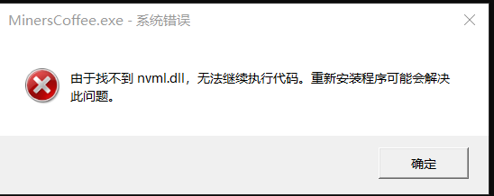

We are suggesting you use NVIDIA GPU.

### Daemon

The button at the top of the software does not completely close the software. We will hide the UI and prompt you to continue using the software in the background. You can find our software icon in the back-end, click it to show the UI.

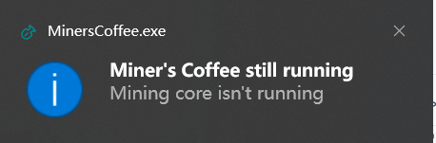

### Turn off

You can enter ctrl + C in the supporting terminal to stop the software, or enter the background program, right-click the icon, and click close.

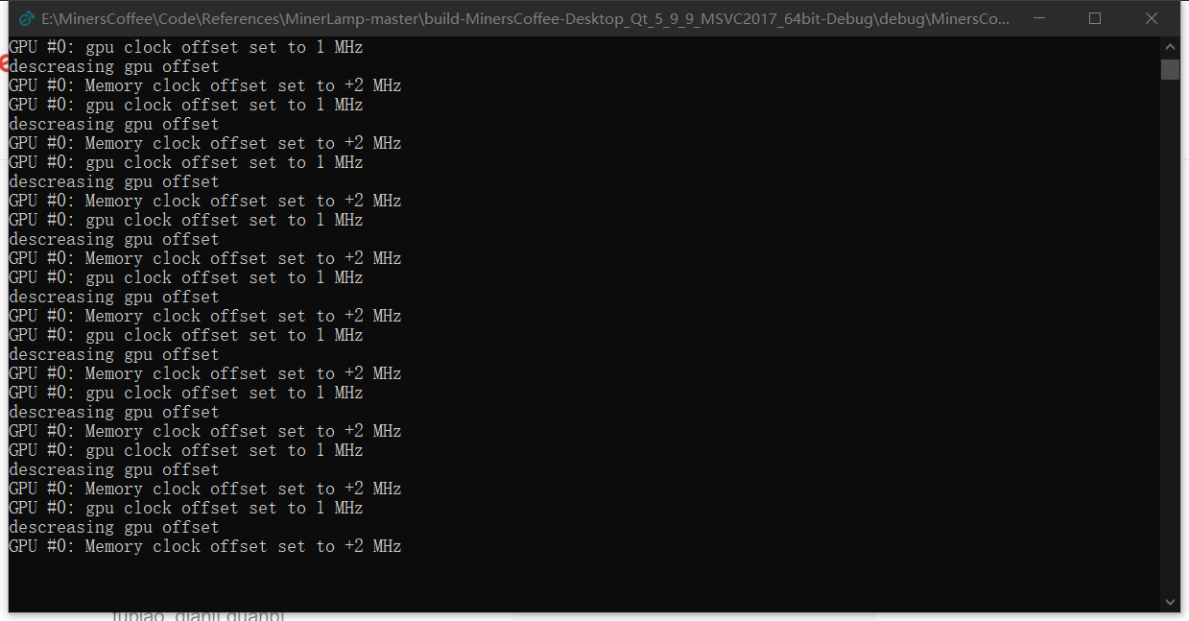

## Software overview

### Navigation bar

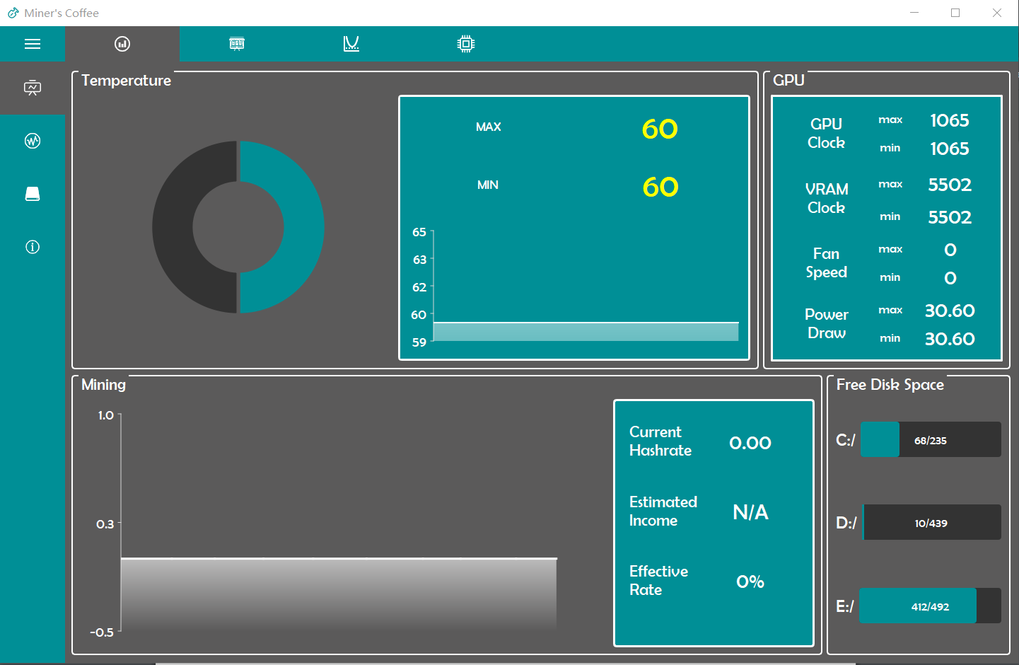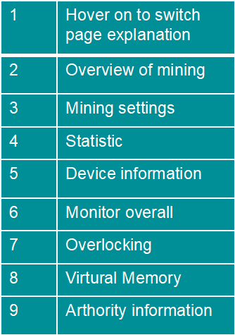

### Monitor

### b4cb433d8a21ebc949467c741f8be4f

|  |  |
| --- | --- |
| Temperature module | Display the value of max and min temperature of all your devices on real-time.  Show max temperature history on the chart. |
| GPU module | Display max and min GPU Clock\VRAM Clock\Fan Speed\Power Draw Information among all devices |
| Mining Module | (Only effectively display after starting mining) Display Hashrate\Estimated income\and Effective Rate |
| Free Disk Space | Display your all free disk information |

### Mining

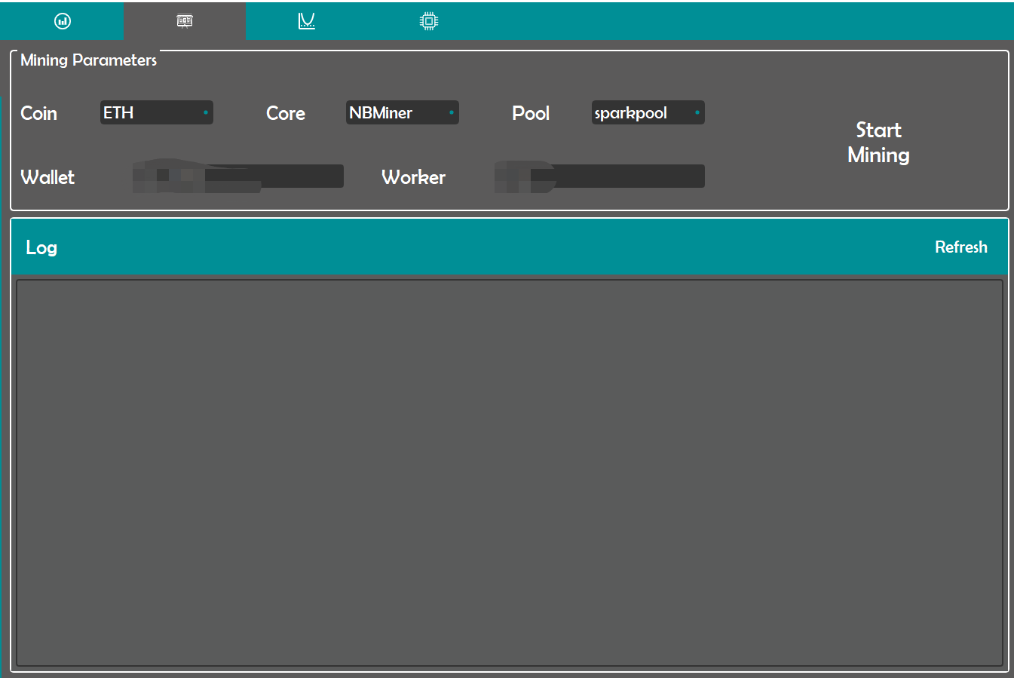

|  |  |
| --- | --- |
| Mining Parameters | Select box for your Coin/Core/Pool  Input box for wallet and worker’s name  Push the button to start and stop mining |
| Log module | Display log information for error checking |

### Statistic

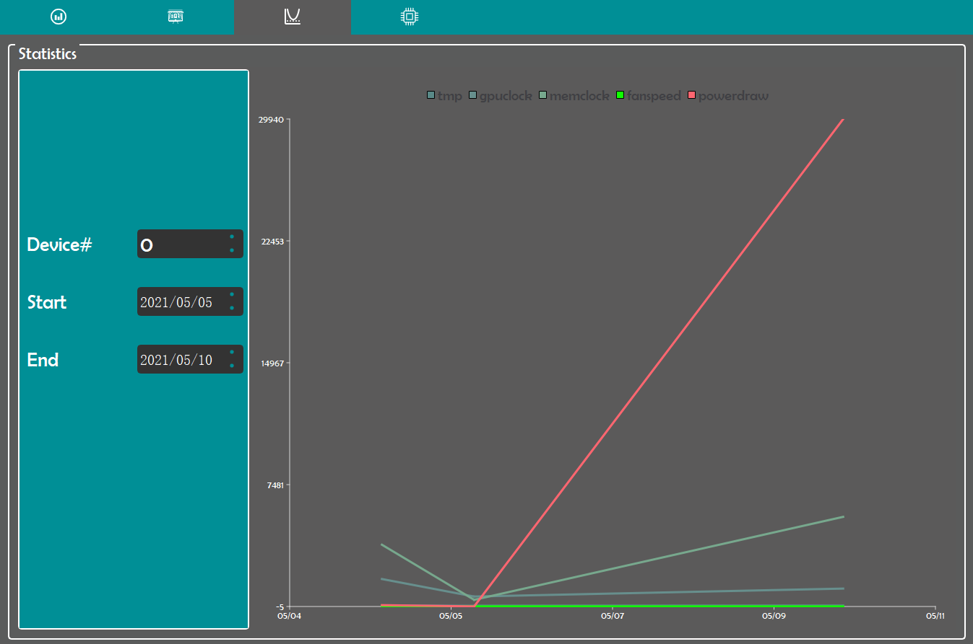

|  |  |
| --- | --- |
| Statistics | Select device and date interval and automatic display the history statistic |
| Device# | Select which device you are interested in |
| Start | Select date for History interval query front end |
| End | Select date for History interval query back end |

### Device information

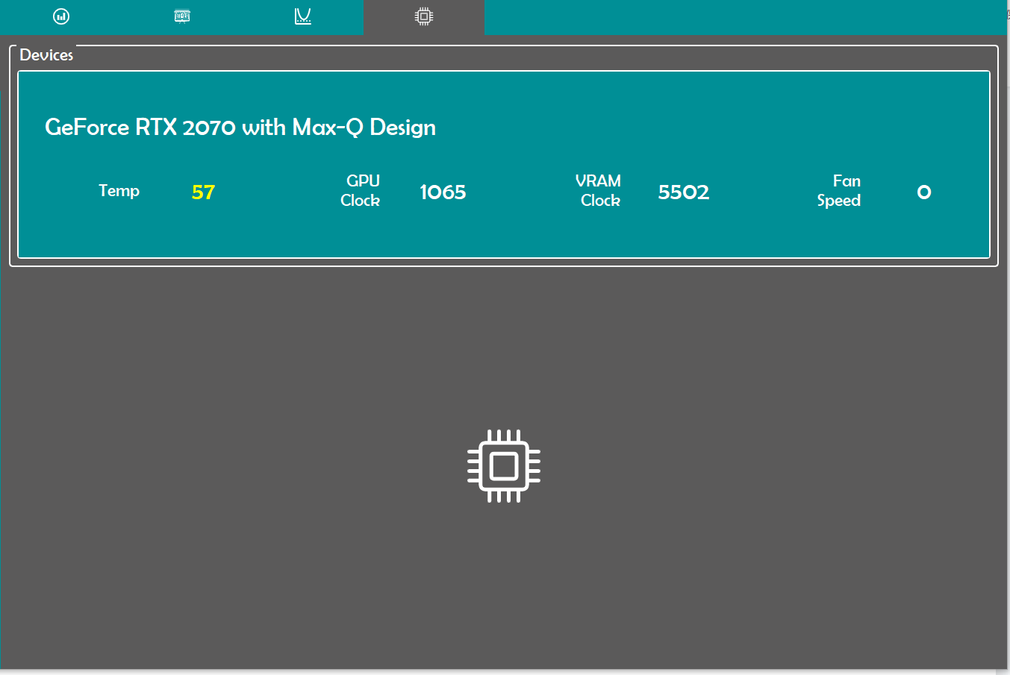

|  |  |
| --- | --- |
| Devices module | Display all NVIDIA devices’ information on your computer |

### Overclocking67ee0b9e47da7f62ff45f700708f6bd

|  |  |
| --- | --- |
| Device number | Select which device you are interested in |
| Temp Limit | Set your temperature limit to protect your Device |
| Group scrolling | Automatically/manually adjust Power limit/GPU Clock/VRAM clock/Fan Speed and push Apply to confirm your adjustment |
| Automatic Settings | Provided choice to set automatic overclocking |

### Virtual Memory settings

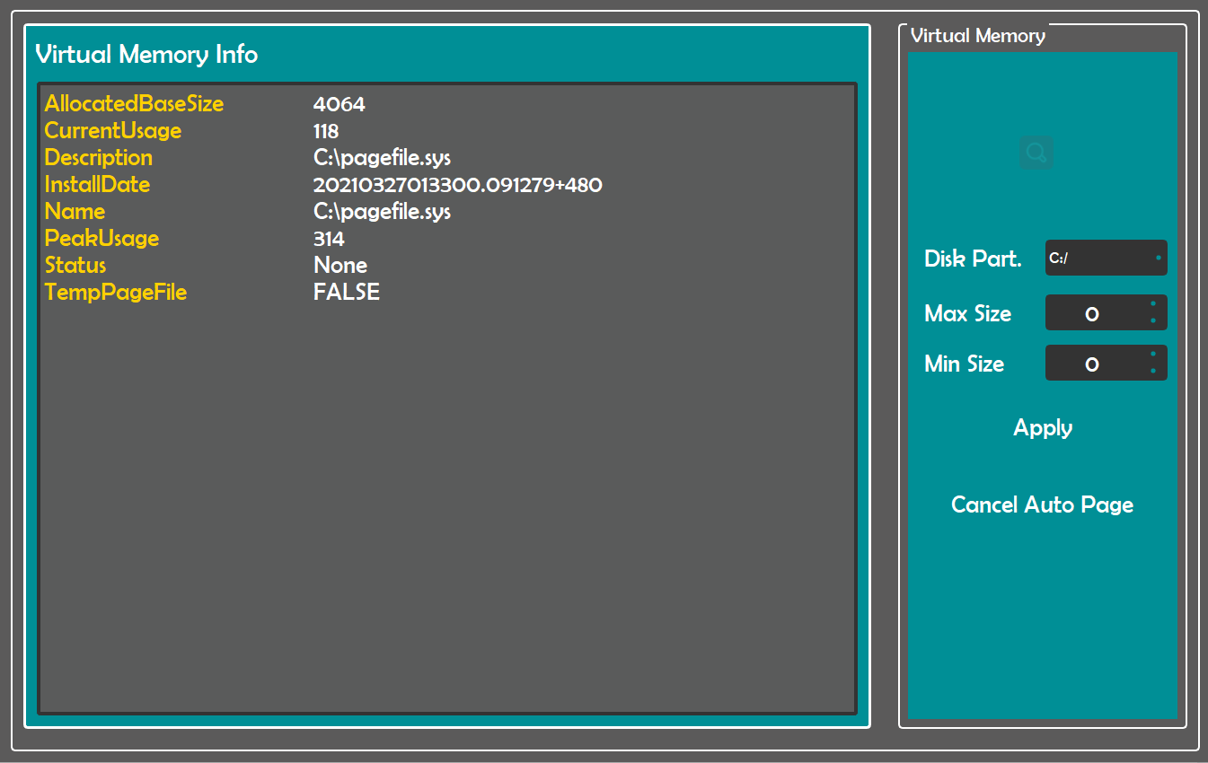

|  |  |
| --- | --- |
| Virtual memory Information | Display information about virtual MEMORY |
| Disk part | Select disk to create virtual memory |
| Max/min size | Set your memory sets |
| Apply/cancel | Push buttons to apply/ cancel apply |

### Authority information

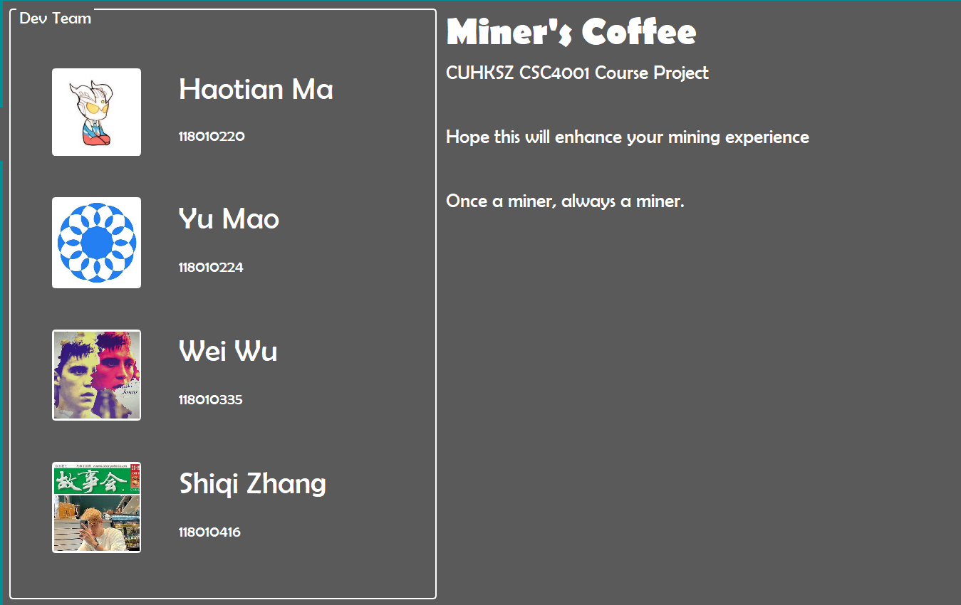

|  |  |
| --- | --- |
| Dev Team | Team members’ information |

## Operation instructions:

Step 1: Complete the information in the mining parameters, especially the wallet name and miner name, and then press the start button to start mining.

Step 2: When a prompt to start mining is displayed in the log, it means that mining has started successfully. If you need to change the mining information, you should press the stop button to stop mining, complete the information again and repeat step 1.

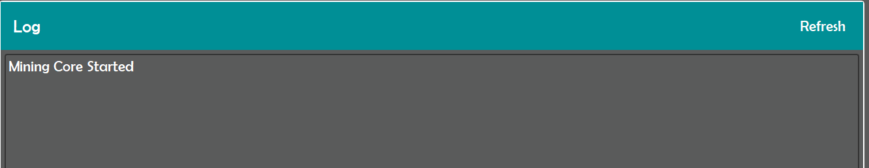

Step3: Observe your GPU temperature changes, Hashrate and other information on the overview page to ensure that your mining progresses normally. After the first few seconds, your estimated income page will display the specific value instead of N/A, as shown in the figure.

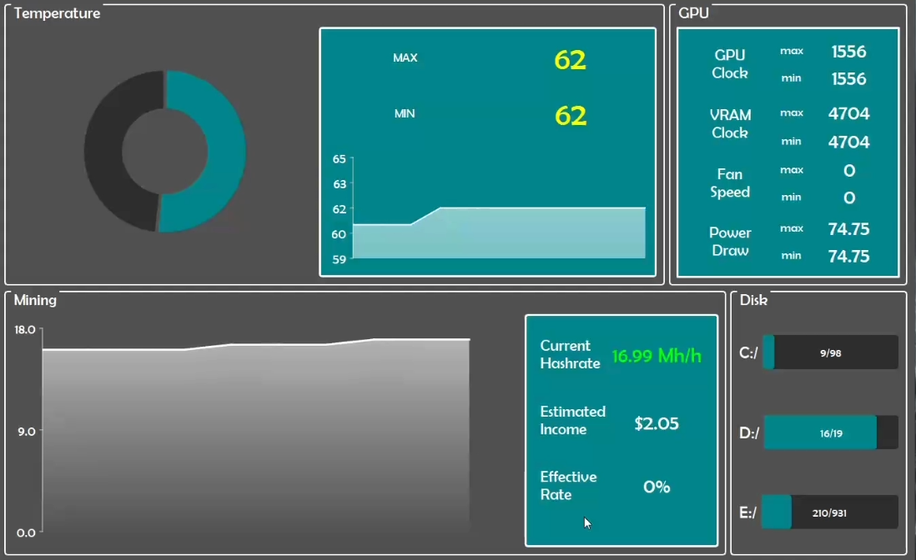

Step 4: You can go to *127.0.0.1:22333* for more specific mining information.

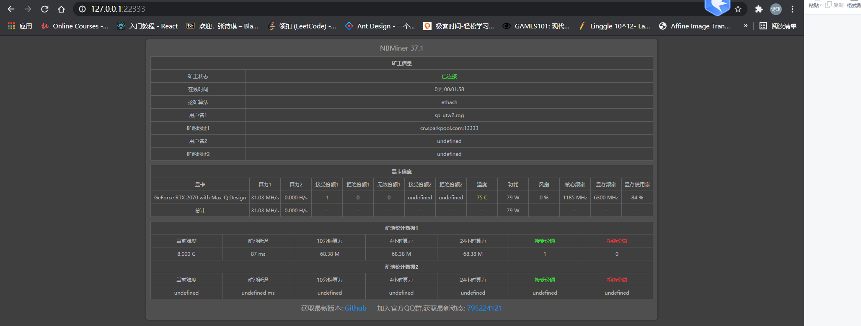

Step 5: On the overclocking setting page, you can get the current value according to the position of the slide bar, slide the slide bar to set the value, click the apply button and then adjust.

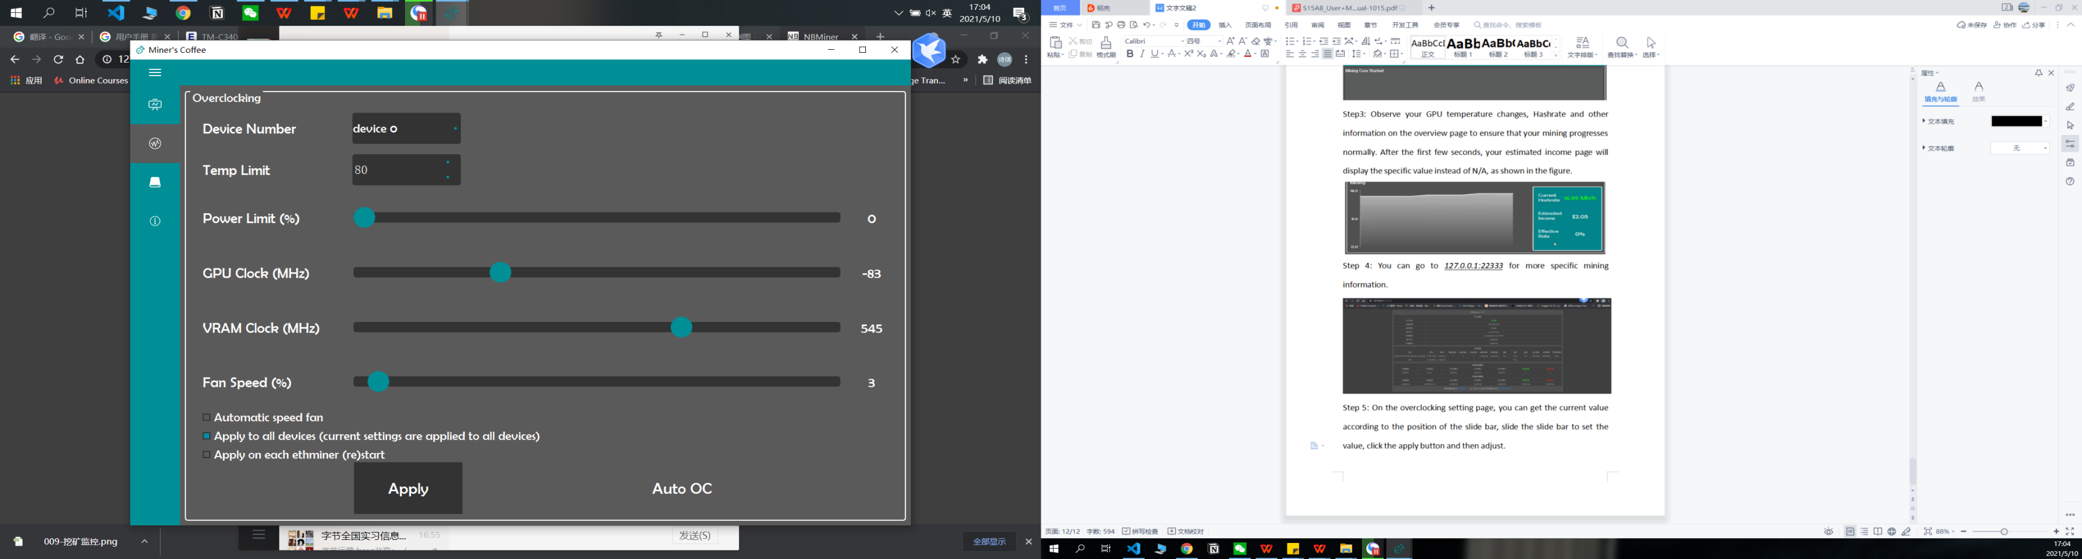

Step 6: Of course, if you are a novice, you can choose to use our automatic overclocking recommendation function, as long as you click the AUTO OC button below, we will set the overclocking according to your GPU type.

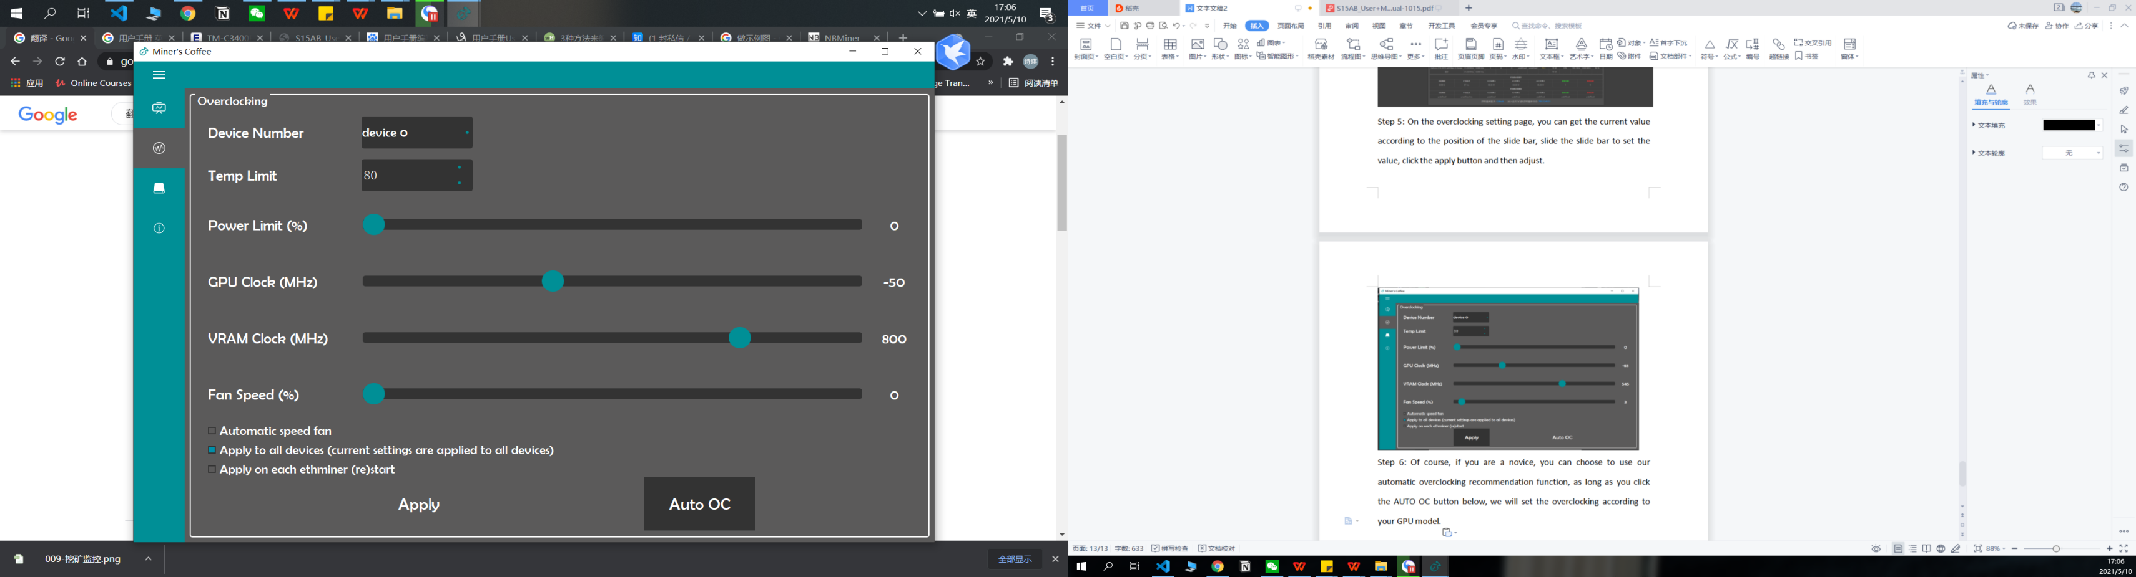

Step 7: View historical data. On the history page, you can select the time interval and device number you are interested in to call up the historical data. The data we display includes temperature, GPU clock, memclock, fanspeed, and powerdraw. You can move the mouse to the icon to zoom the axis

(Please note, please do not check the date in the future or the history 30 days ago)

Step 8: For better use, you can set the virtual memory. You can view the amount of free memory of each disk on the overview page, and then select and set the disk on the virtual memory setting page.

